WE DIG

SQUARE

HOLES!

#### The Brazosport Archaeological Society is an affiliate of the Brazosport Museum of Natural Science and works within its stated objectives, rules, and by-laws.

Meetings of the Society are held on the second Tuesday of each month, at 7:30 p.m. in the Museum, 400 College Blvd., Clute, Texas 77531 (979-265-7831). Or by ZOOM

Lab sessions are held at the Museum. Field trips, excavations, and survey schedules are published in the monthly newsletter, *The Sherd*.

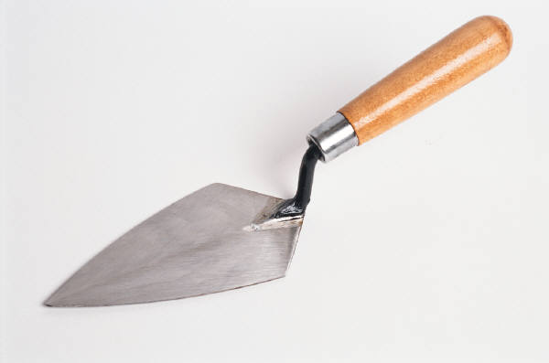

**This Society Strives:**

To preserve and protect prehistoric and historic remains of this region;

To educate members and the public in archeological/ethnological fields;

To conduct archeological studies, research studies and excavations;

To publish data obtained through research studies and excavations;

To co-operate with other scientific institutions and organizations.

**The Brazosport Archaeological Society is a non-profit organization created to stimulate an active interest in the discovery, conservation, and salvage of archeological sites, and the recording and preserving of archeological remains using scientific procedures.**





Participate in excavation, mapping, documentation, lab processing, report writing, archival research, as well as field trips and good clean (sometimes dirty) fun.

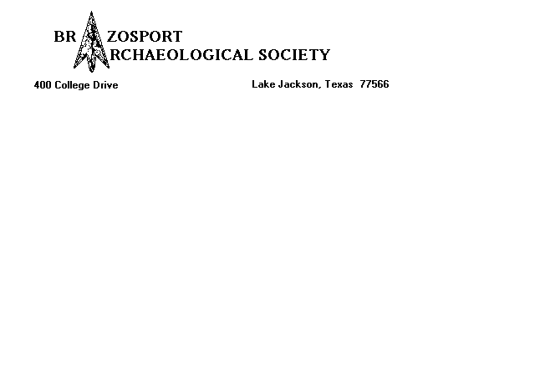

**We invite you to join us in the study of the prehistory and history of**

**Brazoria County.**

**Types of Annual Memberships (circle one):**

**Student : $6 Active: $12 Family: $20 (due in Sept)**

**Contributing: $24 Life: $250**

**Name _________________________________ Phone ( _____) _____________**

**Address____________________________________________________________**

**City ____________________________________ State _____ Zip _____________**

**E-Mail address _____________________________________________**

___ **I would like to receive my newsletter via E-Mail.**

**All individuals applying for membership, shall be obliged to sign the**

**following statement:**

“I, __________________________________________________________, pledge

that I will not intentionally violate the terms and conditions of any present or future

concerning cultural resources, or engage in the practice

of buying or selling artifacts for commercial purposes, or engage in the willful destruction

or distortion of archaeological data, or disregard proper archaeological field techniques.”

**Make checks payable to: BRAZOSPORT ARCHAEOLOGICAL SOCIETY**

**and mail to: 400 College Drive Clute, Texas 77531**

Zoom Meeting address: <https://us02web.zoom.us/j/86993013963>

WEB: <http://bmns.org/affiliate-groups/the-brazosport-archaeological-society/>

Plantation survey web: http://bmns.org/affiliate-groups/the-brazosport-archaeological-society/plantationsurvey/

