LOCATION OF THE EARLIEST WHARTON FAMILY CEMETERY

AT THE EAGLE ISLAND PLANTATION

Johnney T. Pollan Jr. – October, 1984

Updated: November 2022

INTRODUCTION

The Brazosport Archaeological Society has located the earliest Wharton family cemetery on the former Eagle Island Plantation (see Figures 1 and 2). This was done in response to the requests by local historical groups making preparations for Texas' sesquicentennial celebrations. This cemetery was used from the late 1830s to the early 1860s. At least three men instrumental in the creation of the Republic of Texas are buried in this place: William H. Wharton, John A. Wharton and Dr. Branch T. Archer. Remnants of marble slabs that once covered the graves were found along with two tombstones. Brick-rubble-filled postholes were found that mark the boundary of the cemetery.

HISTORICAL BACKGROUND

The original owner of the Eagle Island Plantation was Col. Jared E. Groce.

He abandoned large plantations in Georgia, Alabama, South Carolina and other areas of the old south to build a new cotton dynasty in Texas. He was granted five leagues (22,140 acres) of land in the Stephen F. Austin colony in 1821 from the Mexican government. He divided this land into three plantations, the Lake Plantation (later the Lake Jackson Plantation), the Evergreen Plantation and the Eagle Island Plantation. Each of these plantations was run by an overseer and administered by Col. Groce's son, Leonard Groce (Berlet 1971:15).

On December 5, 1827, Col. Groce gave his only daughter, Sarah Ann, the Eagle Island Plantation as a wedding gift. A few weeks after the wedding, Col. Groce told his brother in Mobile, Alabama that he wanted an exact copy of a mansion that he had seen there to be built for his daughter and son-in-law. This house was probably the first "ready cut" frame home to be built in Texas. Every plank assembled in Mobile. The beautiful stairway, window facings, doors, and trimmings were made from mahogany imported

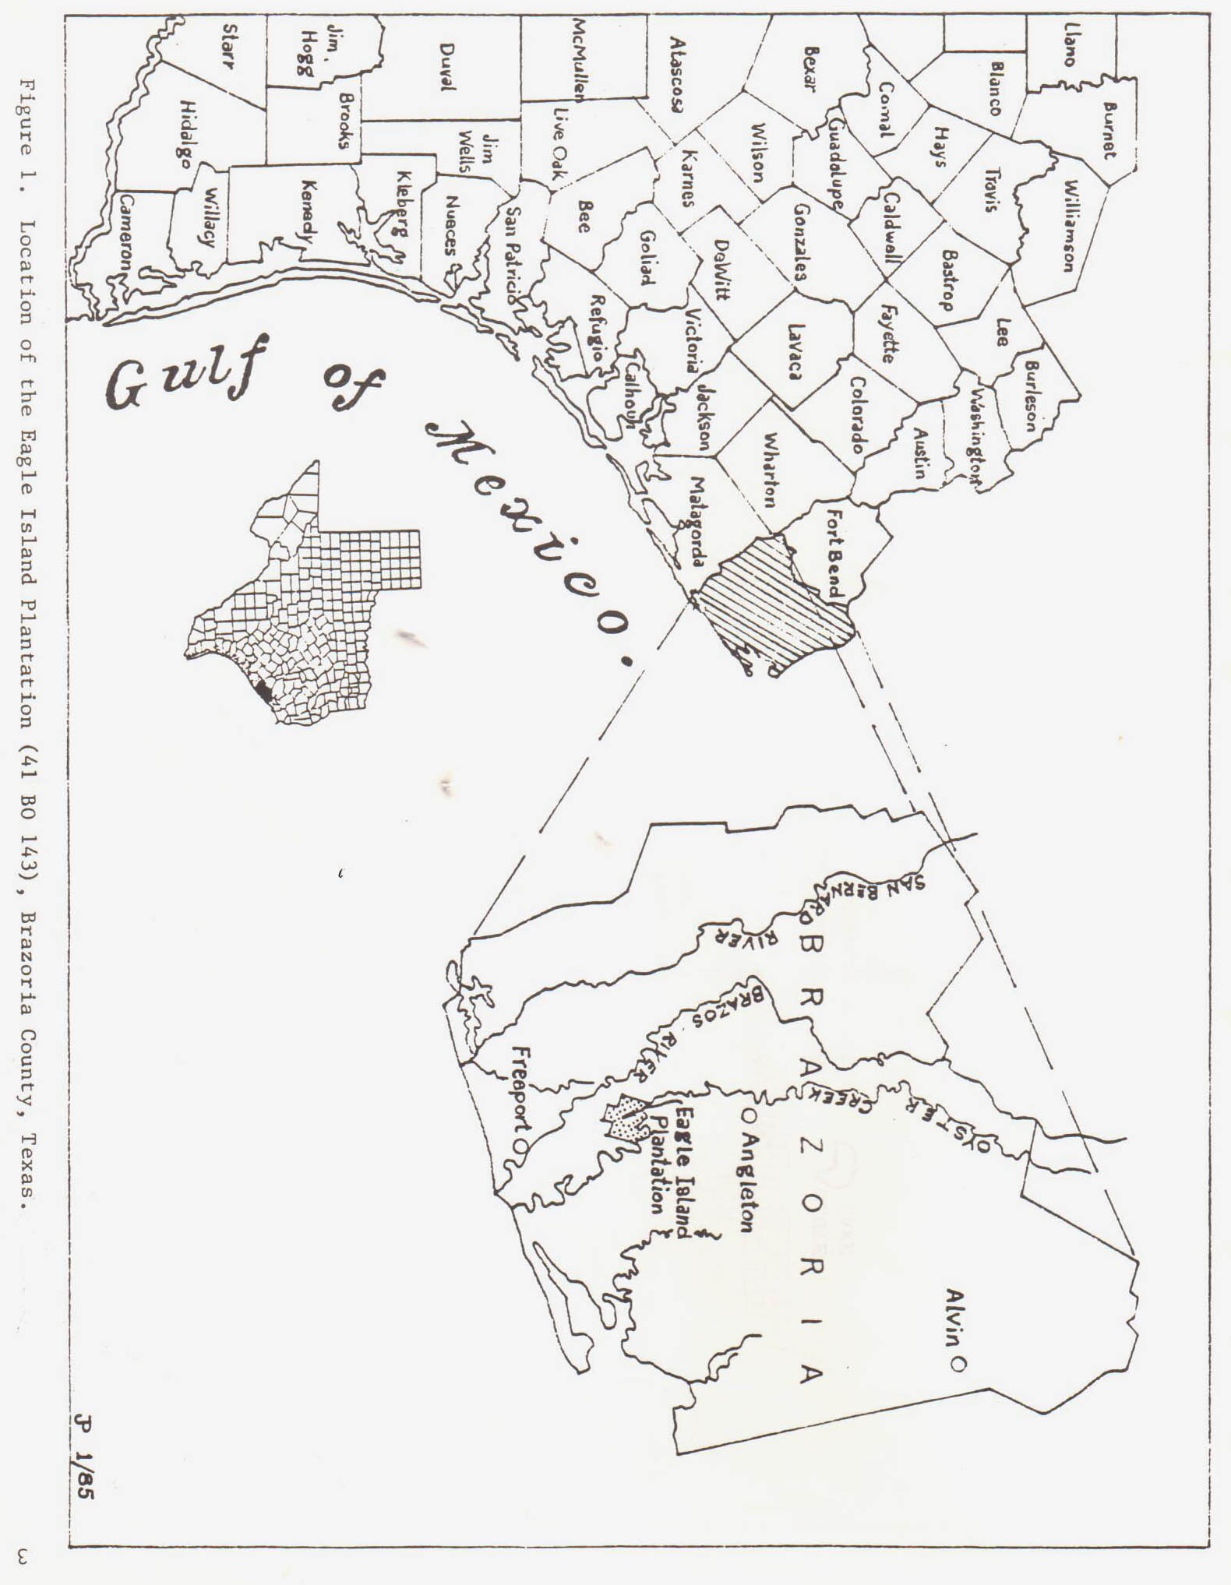as numbered when it was cut and everything needed to build the home was 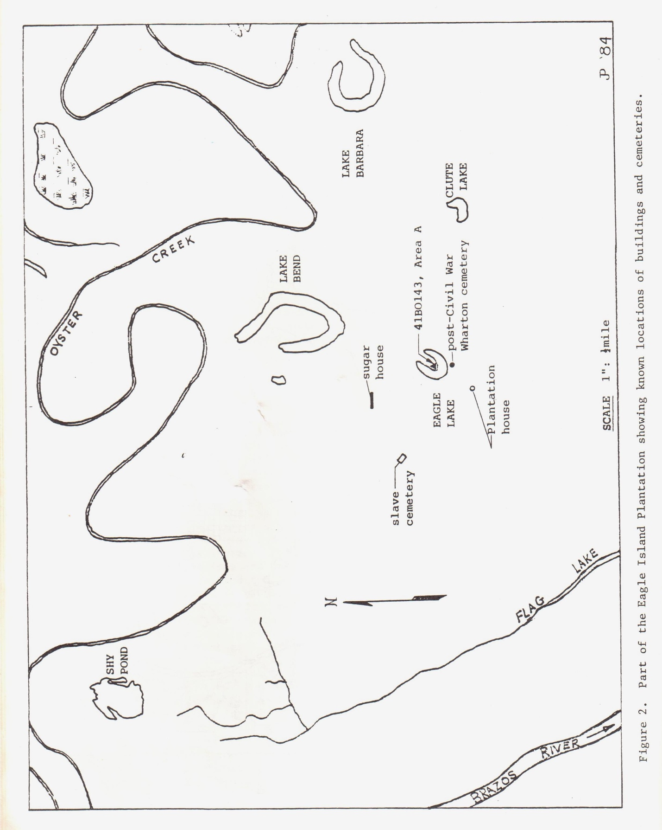

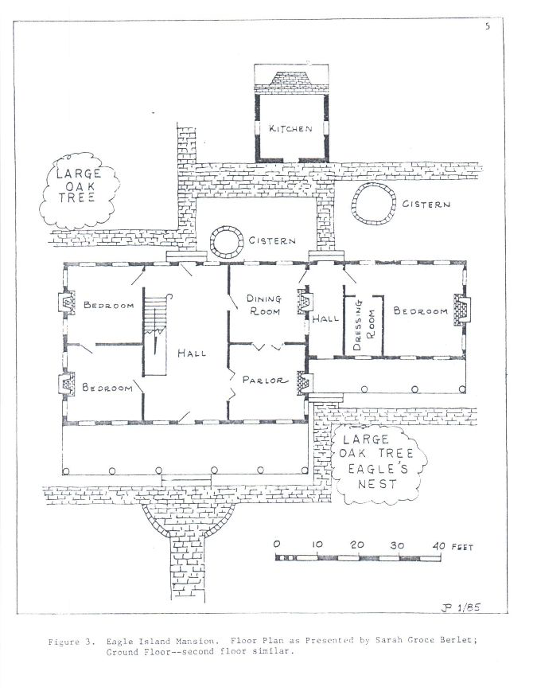

from Cuba. The entire "home kit" was shipped by boat to a landing on the Brazos River as near to Eagle Island as possible. Col. Groce's skilled slaves and overseers supervised the erection of the home. Bricks were

made from Brazos River clay and fashioned into foundations, walks and chimneys.

The mansion was enormous for those days' standards (see Figure 3). It was 52 feet wide by 98 feet long and had two floors. The lower floor featured a hall 20 by 40 feet which separated two 20-by-20-foot rooms on each side of the hallway. These four lower rooms were used as parlor, dining room, library, and bedroom, with an ell built on the right rear of the home. This ell had an eight-foot corridor leading toward the separate kitchen built behind the home. Another bedroom, 20 by 24 feet, was in this ell. A 12-by-60-foot gallery ran across the front of the house and a 38-foot gallery ran across the ell on the front side of the house (0 'Connel 1959:6). The existing log cabins used by the overseer and slaves since 1823 were replaced with frame buildings. The kitchen in which the fireplace took up an entire end of the log building, was left unchanged. The famous library of Eagle Island Plantation was converted to a bedroom by the time it was occupied by Sarah Ann Groce Berlet in the 1870s.

William H. Wharton sent to Scotland for a landscape Gardener to beautify the yard and lake that was near the residence. The beauty of the surroundings was widely known at that time and many prominent people from Texas and abroad were entertained at this exquisite place. The gentle gulf breeze, wide expanse of lawn and the landscaped garden on the lake made it an ideal place to spend the summer.

Mr. and Mrs. Wharton were ideal hosts. Both of them had fine taste, worldly culture, and income sufficient to entertain on a lavish scale (Strobel'1980:37). Their library was one of the finest in Texas at this time.

William Harris Wharton was born in Albemarle County, Virginia, in 1802. He moved to Nashville, Tennessee while still a child. He was orphaned at the age of fourteen. He attended school in Nashville and was admitted to the bar in 1826. After his marriage to Sarah Ann Groce, the young couple returned to Nashville for business reasons. In 1831, William and his family returned to Eagle Island to start a sugar plantation. He purchased a double set of machinery in Philadelphia for use in the sugar house. The purpose for this redundancy was to have the spare parts necessary should a breakdown occur and so avoid any delay in production (Strobel 1980:37). William fought in the battle at Velasco, June 26, 1832, as a member of Capt. John Austin's company. In 1832 and 1833, he served as a delegate from Victoria to the conventions at San Felipe, holding the office of president in the 1833 convention. He, with Stephen F. Austin and Dr. Branch T. Archer, were commissioners to the United States to seek aid for the struggling Texans in their efforts for independence from Mexico. William was appointed the first Minister of the Republic of Texas to Washington City by President Houston in November, 1836. In 1837, William was elected senator and his brother, John A. Wharton was elected representative. The family moved to Houston, then the capitol of the Republic of Texas, and stayed there until the unfortunate accident that took the life of William. It seems that on a visit to Col. Leonard W. Groce, he accidentally shot himself when drawing his holster pistol from its scabbard while dismounting to go in the house.

John Austin Wharton, the brother of William H. Wharton, was born in Nashville, Tennessee, April, 1806. He was orphaned at the age of ten and he and his brother were raised by a wealthy and capable uncle. He was admitted to the bar before he was twenty-one, but found the field overcrowded. He moved to New Orleans in 1830 where he practiced law for three years. In 1833, he joined his brother in Texas. He attended the Consultation of 1835 as a delegate from Columbia, and served briefly as a member of the General Council of the Provisional Government. He joined the Texas army and served as Adjutant General on Houston's staff and participated with valor at San Jacinto. He was elected Representative from Brazoria for the First and Third Congresses. He died in December, 1838, and was buried with military and Masonic rites. His funeral oration was delivered by former President David G. Burnet. President Burnet said of him, that "he was the keenest blade on the field of San Jacinto". He was buried in Houston, but later his remains were removed to Eagle Island (Berlet 1971:35). When Wharton County, Texas, was organized in 1846, it was named in honor of the role of the Wharton Brothers in the building of the Republic of Texas.

Waller Wharton was born to William and Sarah Ann in Nashville, Tennessee, in 1829. William changed his son's name to John A. Wharton shortly after the death of his brother. When William died, Sarah Ann devoted her life to the rearing of her only child. He was sent to South Carolina to attend college, and when he finished, he read law under the Hon. William Preston, the famous lawyer and statesman of Columbia, South Carolina. He married Penelope Johnson, the daughter of the governor of South Carolina. John was elected Attorney of Brazoria County and later Sheriff. When the Civil War started, he raised a company and became a member of the 8th Texas Cavalry, better known as Terry's Rangers. On the death of Col. B. F. Terry, he was elected colonel of the regiment. He finally rose to the rank of Major General, with command of all Cavalry west of the Mississippi River. He survived the war only to be killed by one of his former command, Col. George Baylor, at the old Fannin House in Houston.

With the death of her son, Sarah Ann undertook the task of rearing and educating John's only child, Kate Ross Wharton. In 1871, Kate Ross died at the age of eighteen. In 1876, Penelope Johnson Wharton died leaving Sarah Ann alone. An impoverished Sarah died in 1878 and was buried near her granddaughter and daughter-in-law on the south side of Eagle Lake.

By 1879, only 3,325 acres remained of the original plantation. This property was willed to Sarah Ann's nephew, William Wharton Groce (Deed Vol. T, 1879:92). In 1881, he sold 3,125 acres to Harris Masterson for $983.57 (Deed Vol. T. 1881:342). This money was used to pay off debts incurred by Sarah Ann before her death. William Groce retained the residence including 200 acres of land as a homestead. Masterson sold the 3,125 acres to a northern syndicate who in turn subdivided the property into small farms and sold them. In 1892, Leonard C. Groce, acting as guardian for William Wharton Groce's two daughters, Sarah Ann and Kate Willene, sold the remaining 200 acres including the house to D. R. Pearson for $325.00 (Deed Vol. 17, 1892:177). The 1900 hurricane destroyed the house and the remains were used to repair other damaged homes in the area. Through the years, traces of the home and the family cemeteries by the lake gradually disappeared under silt and vegetation. The property was acquired by the Brazoria Cemetery Association and Restwood Memorial Park was initiated when the first burial lot was sold in January, 1946. The present cemetery has engulfed the site of the residence and its outbuildings. The urban growth of the cities of Lake Jackson and Clute have also taken their toll on the few remaining buildings and occupation areas of the plantation (i.e., the sugar house, slave quarters and slave cemetery).

PRESENT WORK

In December 1983 members of the Brazosport Archaeological Society located the remains of the earliest Wharton family cemetery (41 B0 143, Area A). From a map drawn by Sarah Ann Groce Berlet, the approximate location of the cemetery was shown to lie on a point of land directly across the small lake from the graves of Sarah Ann Groce Wharton, Penelope Johnson Wharton and Kate Ross Wharton. Using probes, a number of pieces of flat marble were found. These pieces were approximately 1 1/2 inches thick and were remnants of larger slabs.

A datum was established near a large pecan tree and an area of 50 feet by 90 feet was laid out into 10-foot grids. Continual probing located 38 pieces of marble and 26 brick-rubble-filled postholes that once supported the wooden fence that formerly marked the cemetery boundary. The cemetery is rectangular, 40 feet 6 inches by 73 feet 10 inches and oriented north to south along its longitudinal axis (see Figure 4). Two 16-foot openings existed at the north and south ends. At the southeast corner, a five-foot space between postholes may indicate a gate-way. Generally, the posts were set eight to nine feet apart (center to center) and buried two feet deep. Posts were three to four inches square and located either in the center of the posthole or placed against the wall of the posthole. A remnant of one of the posts was found still in its posthole. This remnant appears to be oak.

A collection of 13 marble fragments was discovered in the northwest section of the cemetery. Nine pieces were one and one-half inches thick, which, when fitted together, formed one end of a large slab. The original slab had been two feet wide, but its length could not be determined from the remaining pieces. The edge of this slab is lipped, possibly indicating its use as a lid. The remaining four marble slabs are each nearly one and one-half feet long, two inches thick and six inches high, with one edge carefully dressed to a flat surface. These slabs seem to have formed the side walls of the grave on which the slab that served as a lid could have rested.

Just south of this mass of marble, three human skull fragments were found.

Two of the fragments were portions of a cranium and the third was part of a mandible. Three short, square nails, one and one-half inches long, were found among the marble fragments. There is no doubt that the skull fragments and nails come

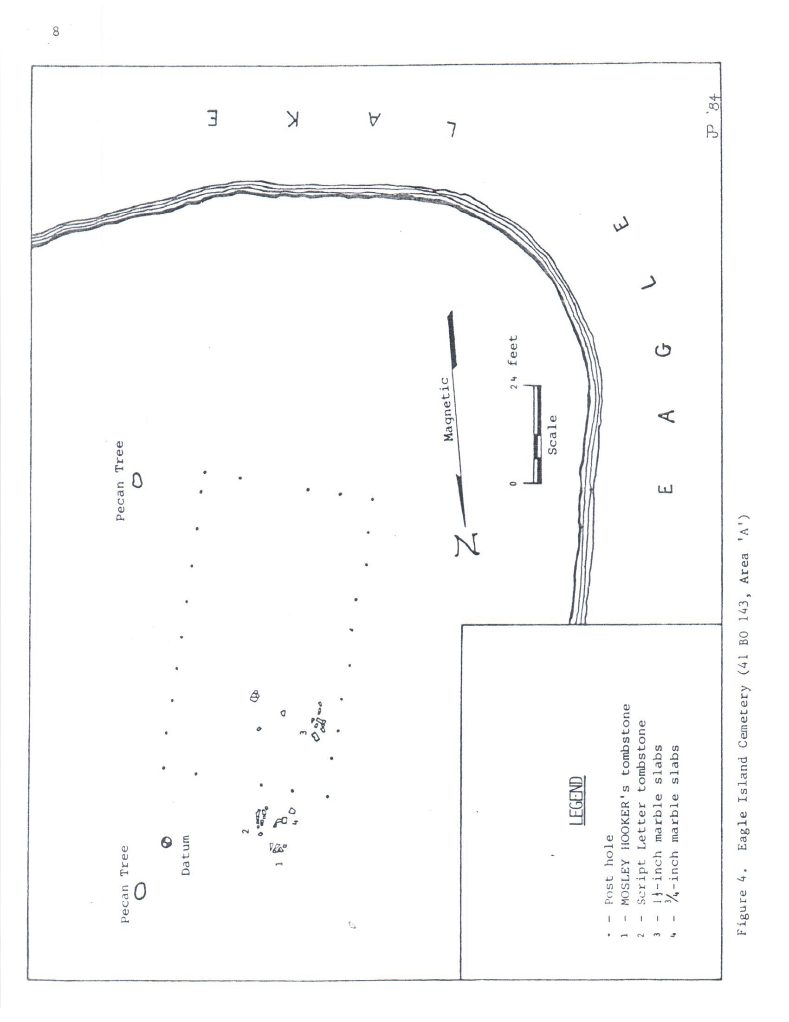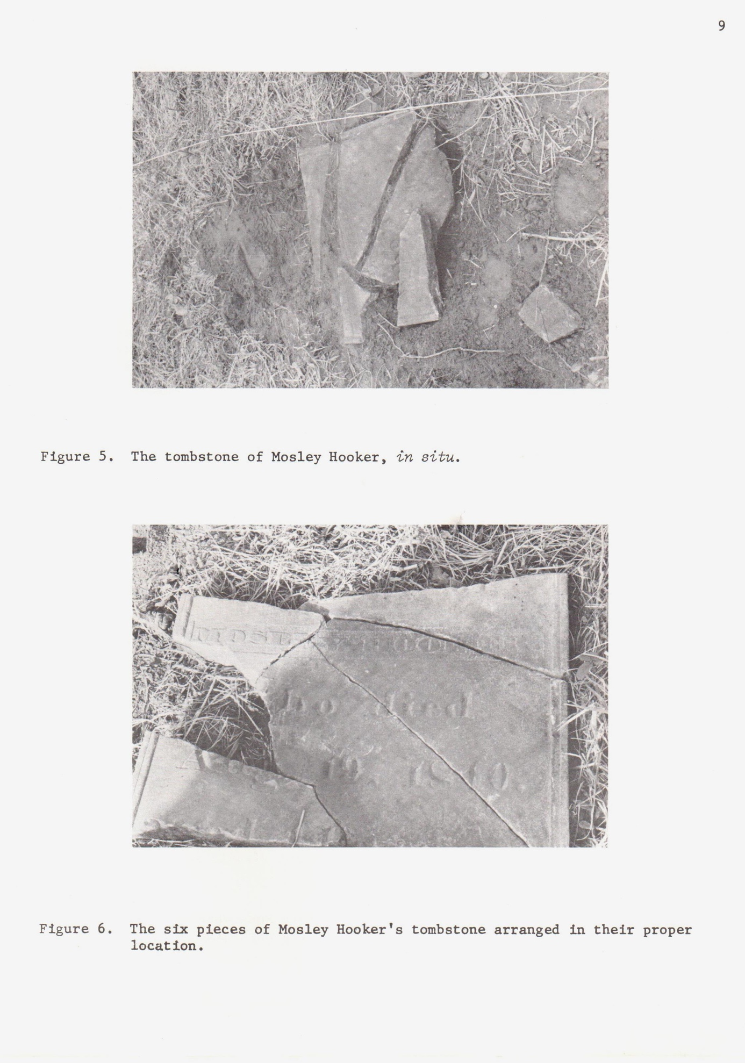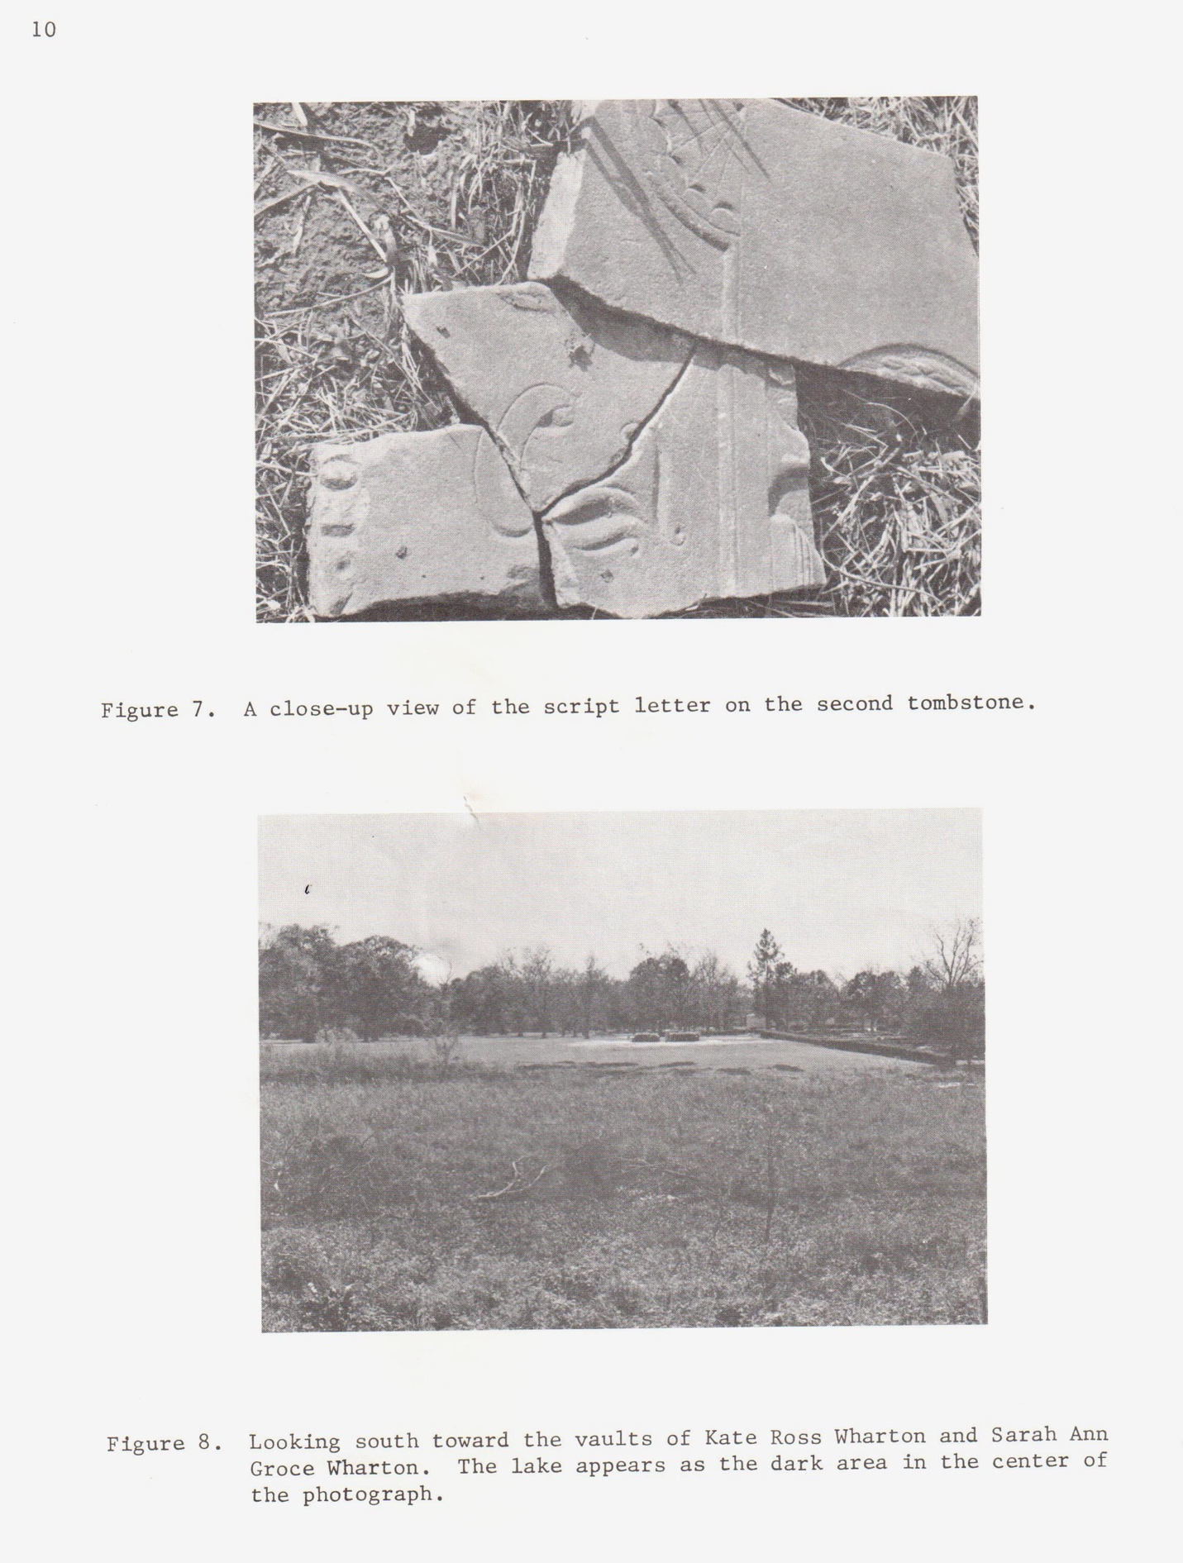

from these burials. How these objects traveled to the surface is not known for certain, but speculation would support two possibilities: looking for valuables buried with the deceased may have desecrated the cemetery sometime after the turn of the century; or the second, and most likely, is that animal activities such as burrowing and den-building disturbed the burials.

Two tombstones were found outside and just north of the cemetery boundary. Only one of the tombstones contained the name of the person for whom it was made. This stone had marked the grave of Moseley Hooker, who died August 19, 1840 and was 44 years old. The stone was approximately one inch thick and broken into six pieces (figures 5 and 6). The second tombstone was only a fragment of a larger and more ornate stone. When fitted together (10 pieces), the tombstone appears to be decorated at the top with a sheaf of wheat. Below this is a large script letter which may be an "F”, a “J” or a “T” (Figure 7). However, nothing could be derived from the faint etching which indicated a text below the script letter.

CONCLUSIONS

This cemetery, located on the former Eagle Island Plantation, was used by the Wharton family and by their neighbors. The earliest known burial made in the cemetery may have been John Austin Wharton's in December, 1838. His brother's, William H. Wharton, followed shortly thereafter in March, 1839. One of the last recorded burials was that of their friend, Dr. Branch T. Archer, in September, 1856. After the civil war, the Wharton family buried their dead across the lake nearer to the residence (see figure 8). William W. Groce stated that the graves of William H. Wharton and John A. Wharton were covered with flat marble slabs and in good condition when he sold the property (Berlet 1971:75). However, the cemetery fell into ruin and when Abner J. Strobe visited the site in the 1920s, he made this observation: “I suppose there are a hundred people buried there, and I am sorry to say the graves have been desecrated. Many of the marble slabs have been desecrated. Many of marble slabs have been removed that marked their last resting place, and now you cannot tell the graves of any--all were formerly plainly marked so one could find them in after years. They must be ghouls indeed who could thus invade the city of the Dead" (Strobel 1980:37-38). The site was rediscovered in 1946, when S. G. Marshall, manager and part owner of the Restwood property, stumbled onto one of the lost gravestones. He found that a tall marble tombstone,

bearing a wheat sheaf design, had fallen and broken into three pieces (0 Connell 1959:5).

It is impossible to identify the graves of individuals without excavating the

burials. Although this might render some information, it most likely would not help to identify whose burial they are. Depressions abound throughout the cemetery terrain, and all of these depressions are potential burial sites.

RECOMMENDATIONS

In consideration of the fact that this cemetery contains the remains of several prominent citizens of the early Republic of Texas, and since the main boundaries of this cemetery have been found, I recommend that this site be added to the list of historical places in Texas and preserved for its historical value. Consequently, should this property be developed, special care should be taken to the north of the cemetery's present boundary since there are indications of possible burials outside these clearly delineated boundaries, such as the two above-mentioned tombstones.

ACKNOWLEDGEMENTS

My thanks to Restwood Memorial Park, Inc. for their willingness to work with the Brazosport Archaeological Society and for giving permission to search their property for the cemetery. Their interest led to the 1984 study of a number of plantation-related structures on their property. I would also like to thank James Smith for his ability to continually supply reference material, which was used to develop the historical portion of this paper. Finally, a sincere thanks to Anne Fox of San Antonio who took the time to provide constructive criticism of the earliest form of this report and for giving much-needed words of encouragement to complete the work.

Report Updated: November 15, 2022

Digitized and updated by: Clint Lacy & James Smith

Edited by: Brenda Jackson

Report is stored on the Brazosport Museum of National Science

Website: http://bmns.org/

Refences

Berlet, Sarah Ann Groce

1971 *Autobiography of a spoon*. La Belle Printing Co., Beaumont, Texas.

Berlet, Rosa Groce

1917 Jared Ellison Groce. *The Southern Historical Quarte*rly, Austin.

O’Connel, Polly

1959 *The Brazosport Facts*, Freeport, Texas.

August 23: Eagle Island – A Gift is a Bride

August 24, Eagle Island – Life on the Plantation

August 25, Eagle Island – Gracious Way of Life Begins

August 26, Eagle Island – Texas Revolt Begins

August 27, Eagle Island – Tragedy Strikes

August 28, Eagle Island – Civil War, Aftermath

August 29, Eagle Island – Conclusion

Kay, Worth S.

1907 *Austin Colony Pioneer*, Pemberton, Austin

Strobel, Abner J.

1980 *Old Plantation and Their Owners of Brazoria County*, Texas. Shelby Publishers, Austin

Unpublished Documents:

Brazoria County Deed Records

1879 Volume S

1881 Volume T

1892 Volume 17